Connections:
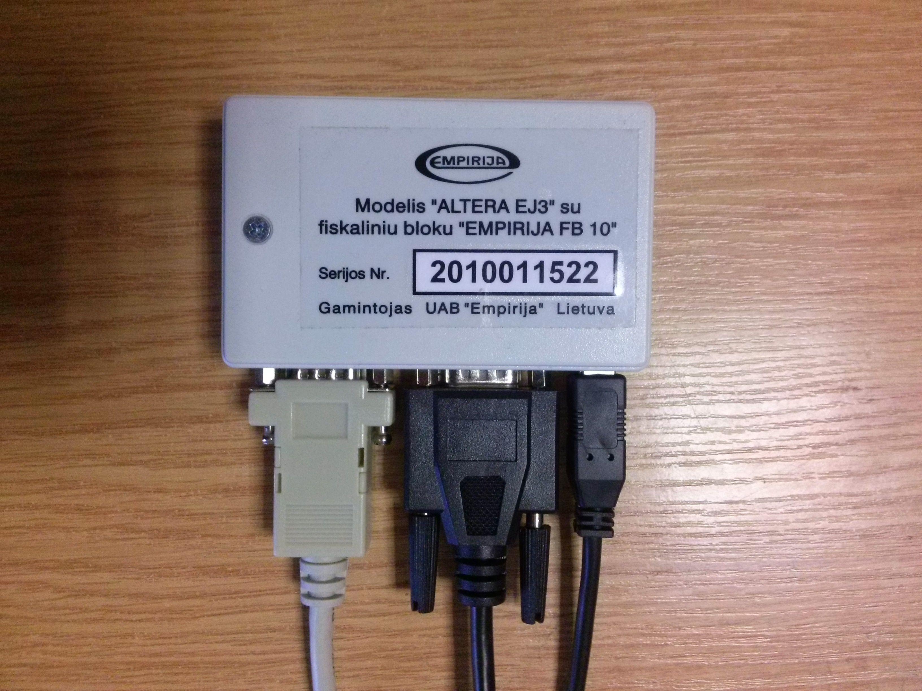
COM Printer USB

EmpiFis POS Software instalation

                - Start EmpiFis POS Setup:
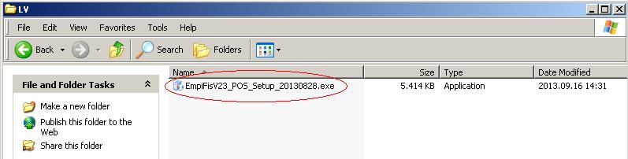
                - Press Next

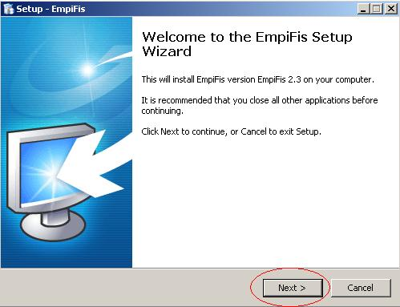
              - Press Next (all sections must be ticked)

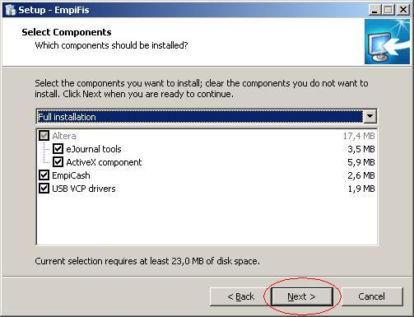
              - Select English language and press Next

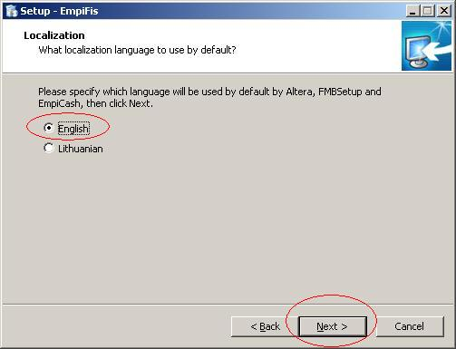

                - Press Install

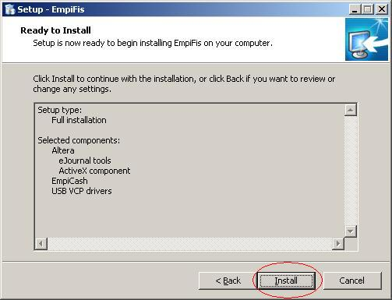

                - Press Extract

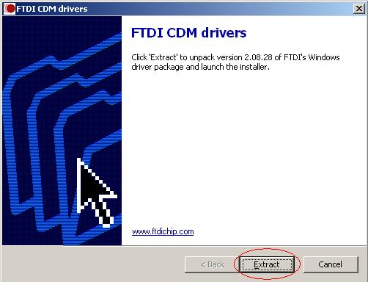
                - Press Next

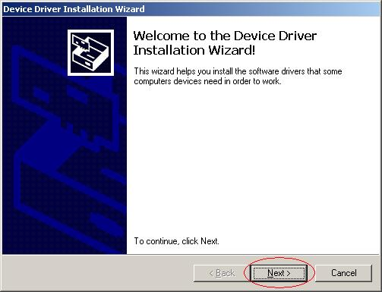

                - Press Finish

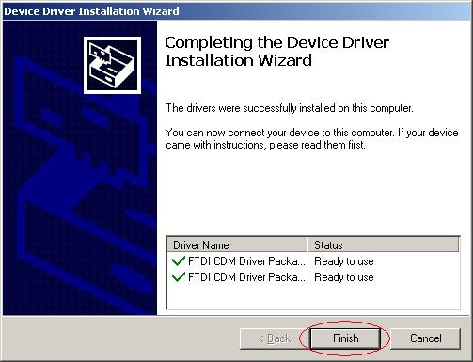
                - Press Finish

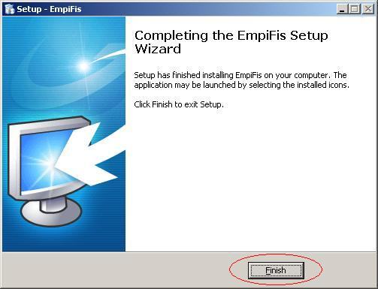

FBM Setup Configuration

1. Working directory is C:\Altera. Make a shortcut of FBMSetup.exe file

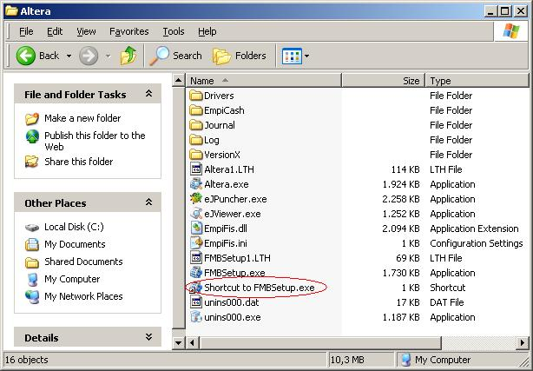
  - With mouse right-click select Properties of Shortcut to FBMSetup.exe and type full afterwards and press OK
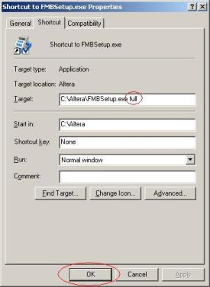

- Run Shortcut to FBMSetup.exe
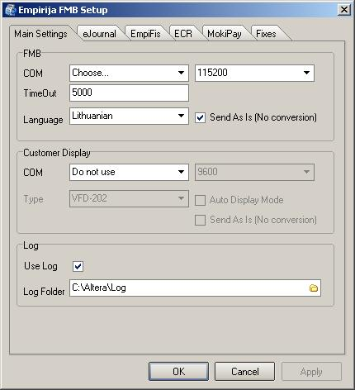

4. Main Settings tab:
„FMB“ section: Choose COM of FMB (COM3 in this case ), set Baudrate – 115200,
TimeOut – 50000, language – Latvian, tick „Send As Is (No conversion)“
„Customer display“ section: Choose COM of customer display (COM4 in this case ),
baudrate – 9600, display type (VFD-202 in this case), tick „Send As Is (No conversion)“
„Log“ section: Tick „use log“, Default log folder is C:\Altera\Log

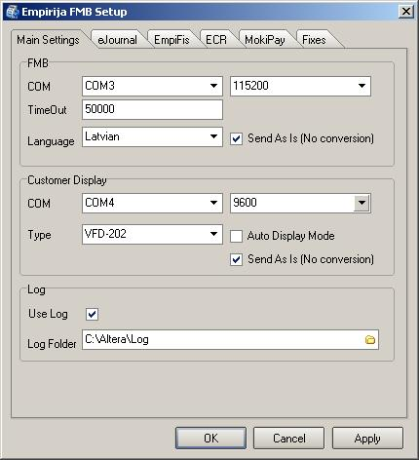

- eJournal tab
Must be ticked Use eJournal and increase Journal Try Count To 15.
Default Journal Folder is C:\Altera\Journal
Default Archive 1 Folder is C:\Altera\Journal\Archive
Archive 2 Folder must be deactivated

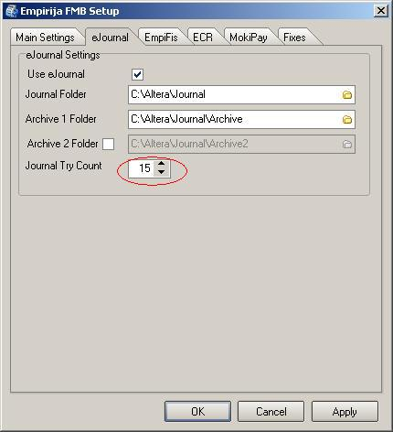

Altera configuration
1. Working directory is C:\Altera. Make a shortcut of Altera.exe file

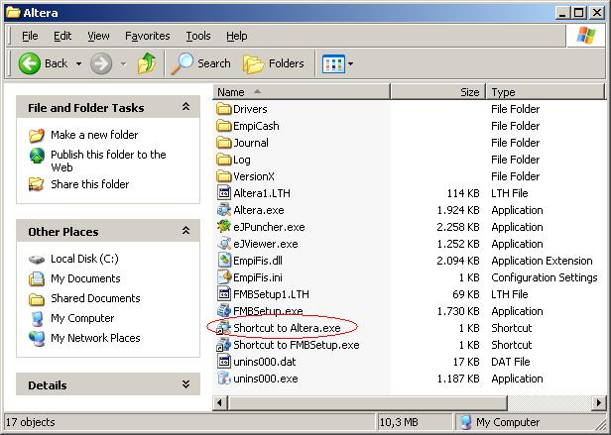
2. With mouse right-click select Properties of Shortcut to Altera.exe and type full afterwards and press OK
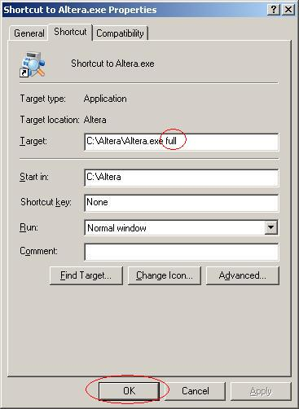

        - Run Shortcut to Altera.exe (if operating system is Win 7 or above run this shortcut „As administrator“ for first time)

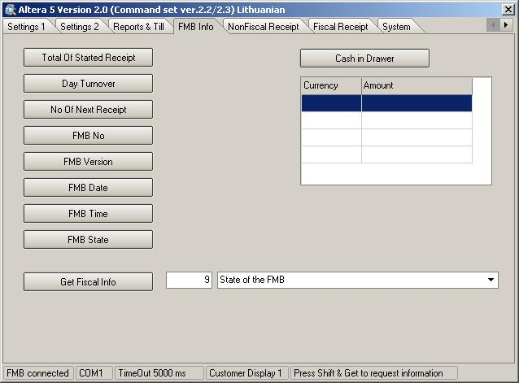
- „FMB info“ tab shows status of fiscal block if you click on each button at the left side

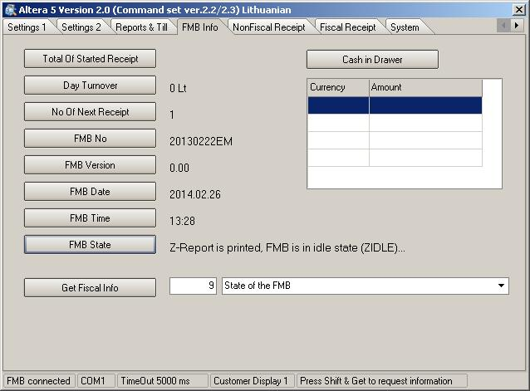

- Settings 1 tab
„Set printer“ section - choose printer type (Orient(80) in this case)
„Set compression“ section – spaces between lines (default is 20)
„Set Till Impulse“ section – impulse count for cashdrawer (must be the same)
„Set Date Time“ section – Date and Time settings
„Set VAT“ section – VAT settings
„Set Currency Table“ section – Currency settings

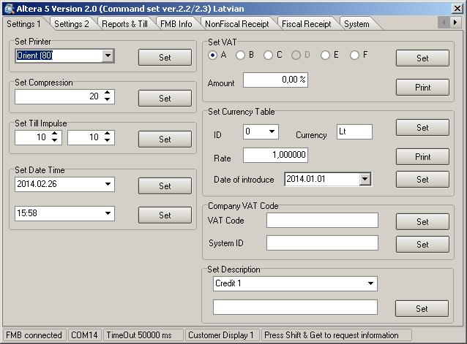

- VAT settings
In VAT section choose letter of VAT and enter Amount of VAT, then press Set

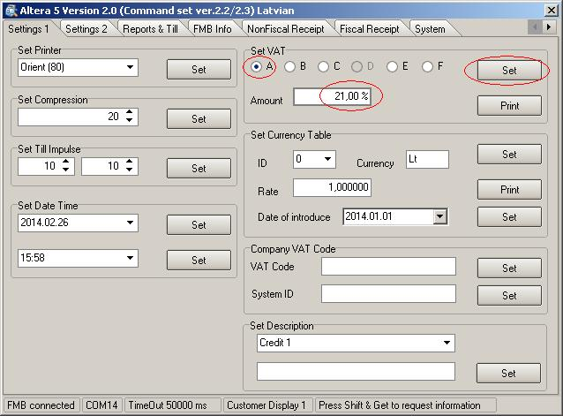

- Currency Setting.
Currency table must be: ID 0 – Eiro, ID 1 – Eiro
To change Currency: Select ID (0), enter currency name (Eiro) and enter Rate (1) and press Set
Then select next ID (1), enter currency name (Eiro) and enter Rate (1) and press Set

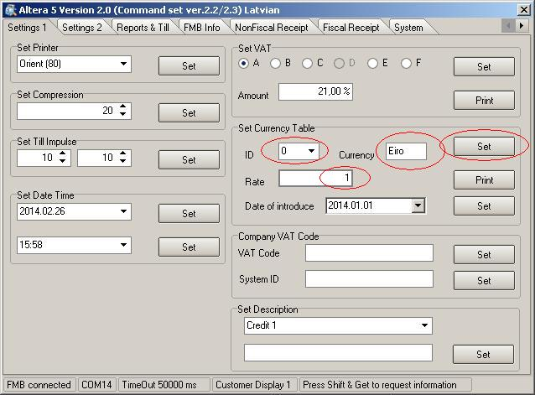

After both ID are entered press Set in „Date of introduce“ line (see picture below)
„Date of introduce“ must be one or more days below present time.

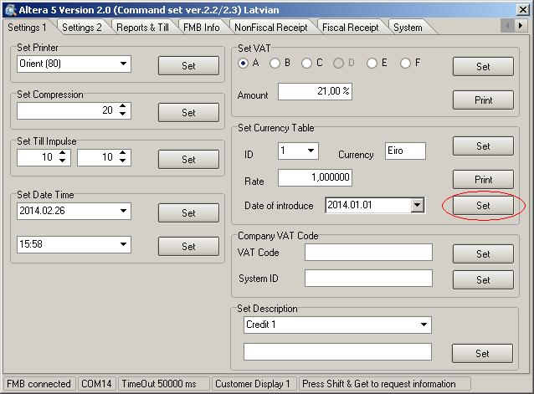
- „Settings 2“ tab is for Header and Footer (if necessary) configurating

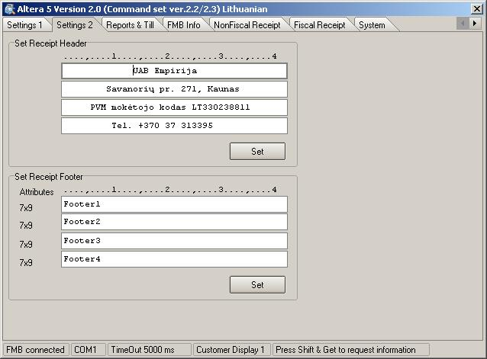
- „Reports & Till“ tab is for printing Reports, open cashdrawer, periodical reports

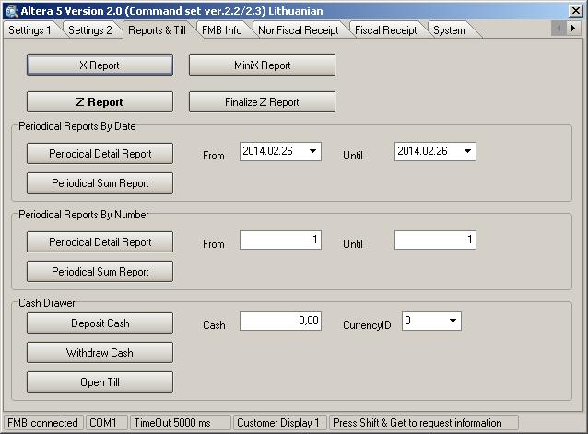
10. „System“ tab
To test customer display press „Customer Display“ button. „DisplayLine1“ and „DisplayLine2“ lines must appear on customer display.
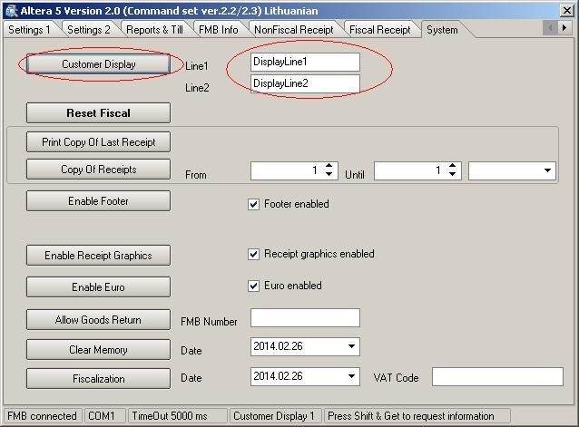

To enable Footer tick Footer enabled and press Enable Footer
To enable logo printing tick Receipt graphics enabled and press Enable Receipt Graphics

For fiscal block Fiscalization type system number ID in field „VAT code“ and press Fiscalization

